Realtek EPON SFU Products

4FE/4FE+CATV/4GE/4GE+CATV
User Manual
Version：V1.1

Content
1 Note 3
1.1 Installation Precautions 3
1.2 Precautions for Use 3
2 Brief 4
2.1 Product Feature 5
2.2 Product Specification 5
2.3 Device Interface Definition 6
2.4 Device Connection 7
2.5 Applications 7
2.6 ONU Instructions 8
3 Login Web Management Locally 8
3.1 Physical Connection of ONU and PC 8
3.2 PC Access the WEB of ONU 9
4 View ONU System Status 10
4.1 View ONU Device Information 10
4.2 View ONU PON Status 10
4.3 View ONU CATV Status Information 11
5 Configure Management IP Address of ONU 11
6 View ONU LAN Information 12
6.1 View ONU LAN User 12
7 ONU Diagnostic 13
7.1 ONU Loop Diagnostic 13
7.2 Ping Diagnostic 13
8 ONU System Management 14
8.1 Register LOID of ONU Config 14
8.2 CATV Settings 15
8.3 Port Isolation Settings 16
8.4 Reboot ONU 17
8.5 ONU Chinese and English Interface Switch 17
8.6 Reset Settings to Default 18
8.7 Modify the Account and password 18
8.8 Upgrade the ONU 19
9 ONU Interface Traffic Statistics 20
9.1 ONU LAN Interface Traffic Statistics 20
9.2 PON Statistics 20
Concluding Remarks 21

Note

Installation Precautions
- Do not place the equipment near flammable or conductive items, high temperatures (such as direct sunlight) or in wet conditions, or on a PC chassis, and check that the surrounding appliances are stable.
- Check the cable for aging. Check and verify that the AC or DC input voltage is within the permissible range of the device and that the polarity of the DC is correct.
- Unless the manufacturer permit, use the type of power indicated on the label and the adapter supplied with the product.
- To prevent damage to the product from lightning, make sure that the ground of the power outlet and the power adapter is securely grounded. In the thunderstorm, be sure to unplug the power and all the connections.
- Equipment input voltage fluctuation should be less than 10%, the power plug, refrigerators, hair dryer and iron should not use the same socket.
- To avoid electric shock or fire due to overload of the power outlet, damage to the cord or damage to the plug, check the power cord regularly. If damage is found, replace it immediately.
- Please place the device on a flat surface and can not place items on the device.
- Equipment is easy to produce heat when working, should maintain the appropriate cooling space to avoid damage caused by overheating products. The elongated hole on the shell is designed for heat dissipation. Keep the ventilation clean and avoid falling from the heat sink into the equipment. Otherwise, the equipment may be damaged or fire. Do not spill liquid onto the surface of the equipment.

Precautions for Use
- Please read the user manual carefully before using the equipment and follow all the precautions on the user manual and the product.
- Avoid eye looked at the optical interface directly, so as to avoid the laser beam emitted by the interface damage the eyes. Please try to wear safety glasses to effectively protect your eyes from damage. It is best to plug in the fiber optic interface jacket when the optical interface is not in use .
- Turn off the power when the device is not in use
- Before plugging the power supply, make sure that the power switch is turned off to avoid surge. Be careful when unplugging the power supply and the transformer temperature may be high.
- To ensure safety, do not open the enclosure of the device, especially when the device is powered up.
- Unplug the power supply before cleaning the equipment. Use a soft dry cloth to clean the equipment to avoid the use of liquids or sprays.
- Do not connect this product to any electronic product unless it is instructed by our customer engineer or your broadband supplier, as any incorrect connection may cause power or fire hazard.

Brief
Realtek EPON SFU series of terminal equipment is based on EPON technology based on the broadband access market, to meet the broadcaster operators broadband access and FTTH, and design passive optical network terminal products that integrate CATV optical receiver and achieve broadband, CATV dual network integration. It is based on mature and stable, cost-effective Gigabit EPON technology and integrate Gigabit Ethernet switching technology, WDM technology and HFC light reception technology, with high reliability, easy management and good quality of service (QoS) and so on. Technical performance of equipment meet the IEEE802.3ah, China Telecom EPON equipment technical requirements (V2.1 / V3.0) and other requirements.
EPON technology is a combination of PON technology and Ethernet technology advantages of emerging technologies, is a point to multi-point networking technology，with high bandwidth, high efficiency, large coverage, rich user interface and many other advantages, is the operator to achieve access network business broadband, integrated transformation of the ideal technology.
The Realtek EPON SFU series terminal devices are equipped with 1-4 10M / 100M / 1000M adaptive interface and a CATV interface. The equipment has been implemented with EPON central office equipment (Huawei / ZTE / FiberHome / Alcatel-Lucent) OLT) interoperability, composed of Gigabit systems, to meet access needs of the two-in-one video, data services, FTTH / FTTO.

Product Feature
- Dual-fiber access, providing broadband, CATV, Wi-Fi, IPTV service access, and so on.
- Equipment technical performance meets IEEE802.3ah, China Telecom CTC 2.1 & CTC3.0 standard
- Support VLAN Transparent、Tag、Trunk、Translation、QinQ function
- Support up and down bandwidth limit function
- Support port loop detection / port link status detection
- Support upgrade through the OLT remote / local ONU WEB
- Support broadcast storm suppression
- Different data ports are isolated from each other
- Support port flow control
- Support multiple multicast forwarding mode: igmp snooping, igmp proxy
- Support OLT as SNMP-agent way of the unified management of the network management, easy to install and maintain
- Provide a variety of fault alarm function, easy to fault diagnosis
- Support AES-128 decryption, support key generation and switching
- Support DBA technology and priority based on the dual management model to ensure that the user's minimum specified bandwidth requirements
- QoS guarantee for different priority services through SLA constraint, Policing, queue management scheduling / congestion avoidance, discard management
- Supports entry-based traffic control, we can select Pause frame to limit.
- Support HQoS Function
- Support CATV service remote shutdown function
- Operating wavelength: 1100 - 1600nm
- Light reflection loss: >45dB
- Input optical power: -18dBm～0dBm

Product Specification
Ambient temperature: 0°C～50°C
Relative humidity： 10% to 90% (non-condensing)
Power adapter input：12 V/1A
TX Optical Power：0~4dBm
RX Opitcal Power：-3~-27dBm

Device Interface Definition

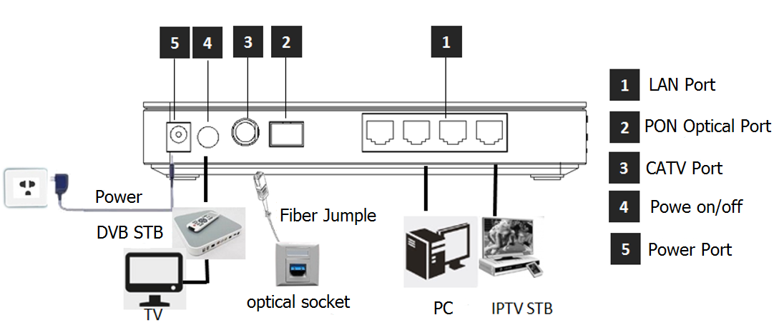

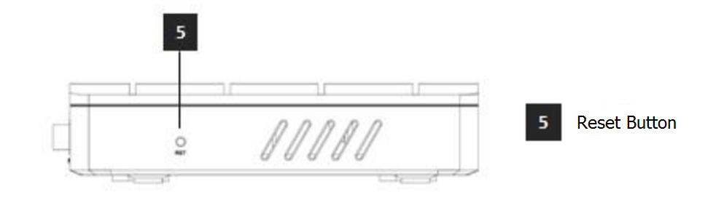
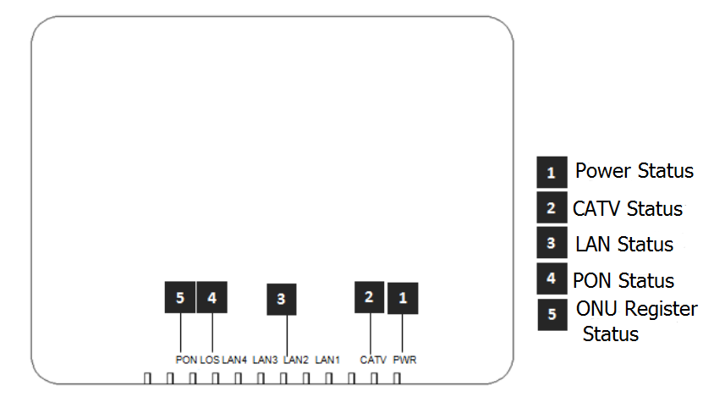

Indicator |  |  | Description
1 | PWR | Power status | On: The ONU is power on;  Off: The ONU is Power off;
2 | CATV | CATV port status | On：CATV optical normal（>-9dBm）  Off：The CATV signals are not received or low（<-9dBm）
3 | LANn | LAN port status | On: Ethernet connection is normal but no traffic;  Blinking: Data is being transmitted through the Ethernet port;  Off: Ethernet connection is not set up or abnormal;
4 | LOS | EPON optical signals | On: Optical power lower than receiver  sensitivity or no optical signal;  Off: Optical in normal
5 | PON | ONU Register | On: Success to register to OLT;  Blinking: In process of registering to OLT;  Off: In process of registering to OLT failed or no normal signal input;

Device Connection
- Connect the fiber: Insert the SC fiber connector into the PON connector on the rear panel of the ONU.
- Connect the Ethernet cable: Connect the RJ-45 Ethernet cable to any LAN port and each home device, that is, the computer, IPTV set-top box, and so on.
- Connect the AC adapter: Plug the AC / DC adapter into the AC wall jack and the ONU 12V DC power jack.
- Press power switch. The equipment can provide business services if the lights are normal after power supply for the ONU.

Applications
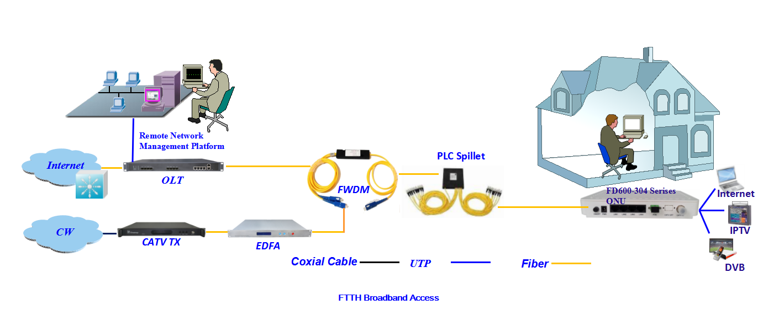

ONU Instructions
Realtek EPON SFU ONU is mainly work in the bridge mode, all the configuration of ONU (ONU port vlan, ONU port speed limit, etc.) are basically configured through the OLT, but also through the OLT and EMS network management to manage, It does not need to be configured on the ONU's local WEB. The configuration manual is to guide customers to do some basic view and configuration operation for Realtek EPON SFU ONU. Other configurations of the ONU can be configured according to each manufacturer's OLT configuration manual.

Login Web Management Locally

Physical Connection of ONU and PC
a) Local NIC of PC connects to LAN port or ETH port of ONU via wires.
b) Set the IP address of PC’s local NIC as 192.168.101.X (X：2-254).
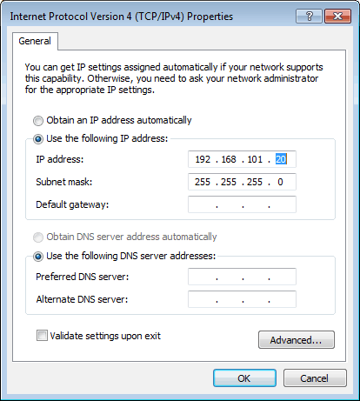
c) Open cmd windows and make sure that PC can ping the management IP (192.168.101.1) of ONU.
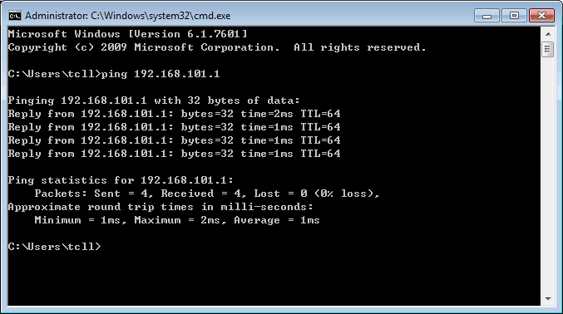

PC Access the WEB of ONU
Make sure you can ping the ONU like #3.1. Open the IE Web broswer (IE, Firefox, Google), copy and paste URL: http: //192.168.101.1, the following pop-up Prompt landin-g page:
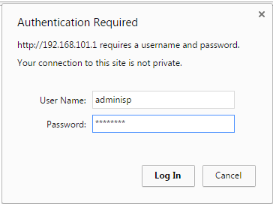

Input UserName：adminisp Password： adminisp
Click “Login” button. The product basics page appears, as follows：
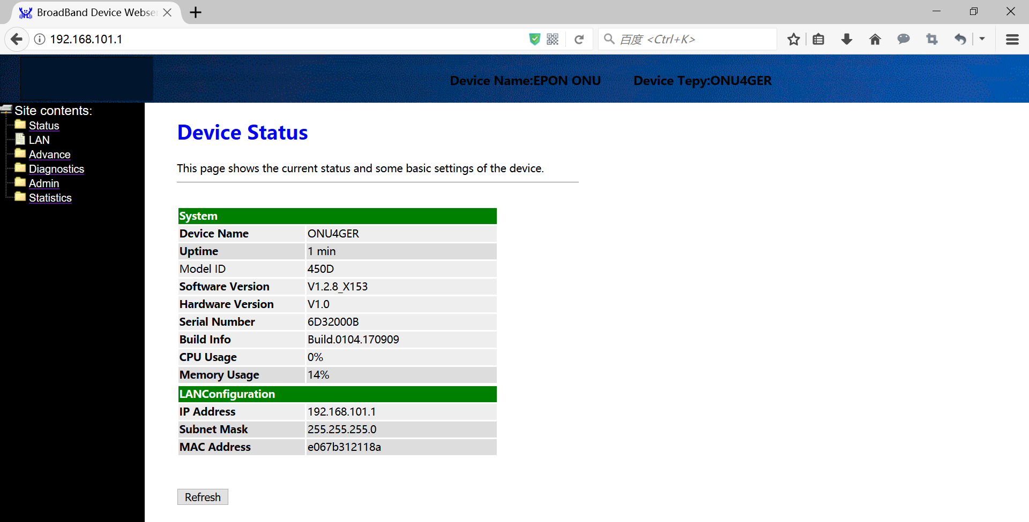
You can start further configuration.

View ONU System Status

View ONU Device Information
Login ONU WEB. Click Status → Device, we can view the Device Name, Uptime, Model ID, Software Version, Hardware Version, Build Information, IP Address, MAC Address and so on.
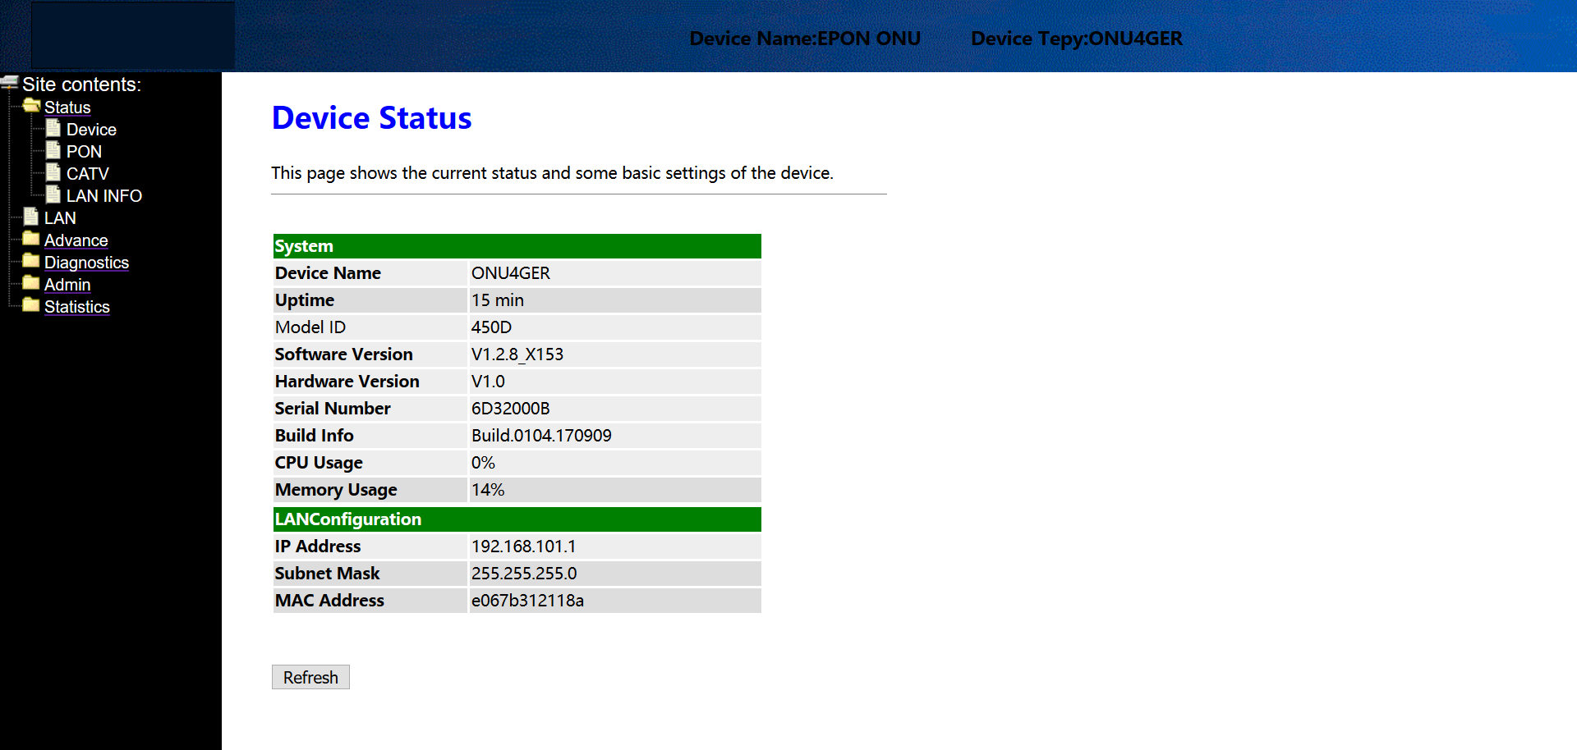

View ONU PON Status
Login ONU WEB. Click Status → PON, we can view the Register Status, Rx Power and Tx Power and so on.
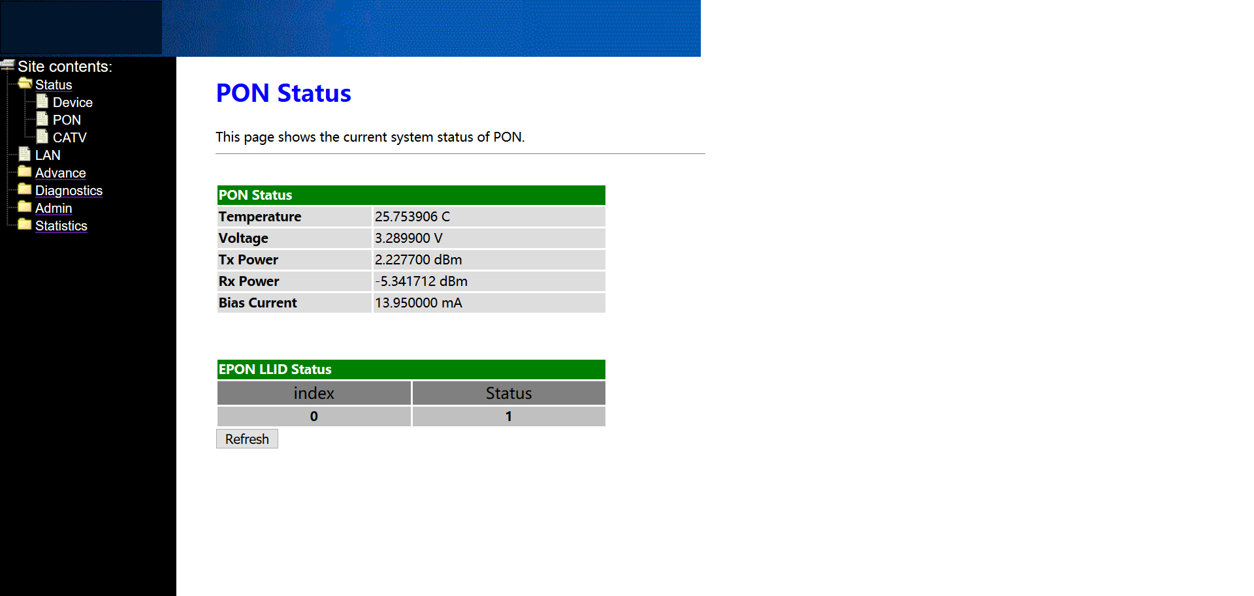

View ONU CATV Status Information
Login ONU WEB. Click Status → CATV, we can view the CATV information.
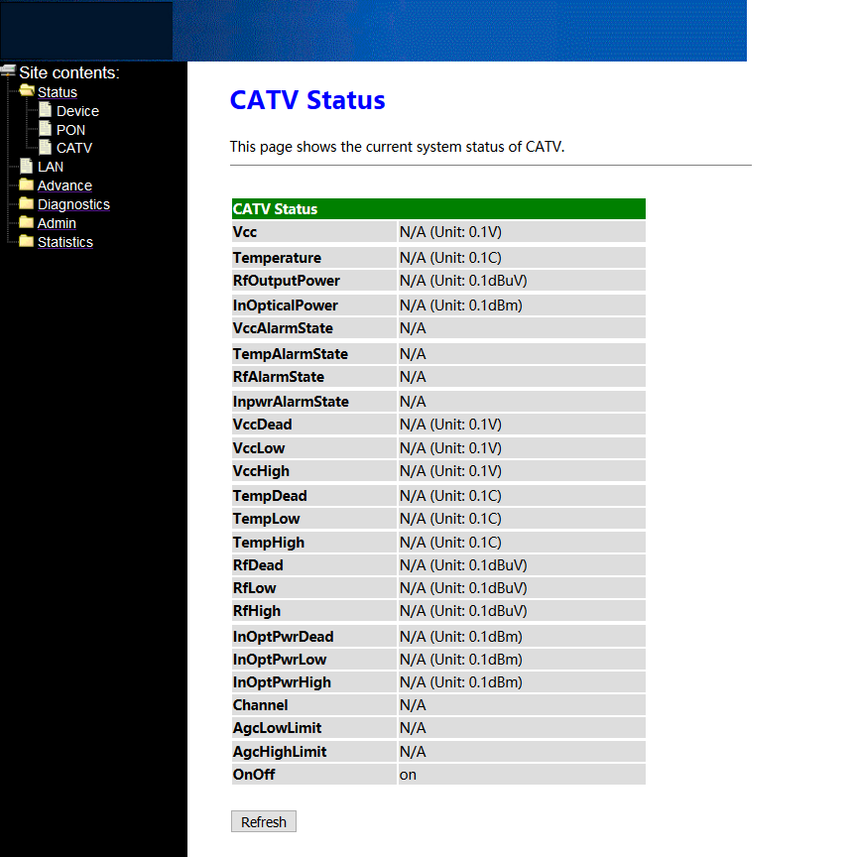

Configure Management IP Address of ONU
Login ONU WEB. Click LAN, we can change IP address and subnet mask of local management and remote management. Normally, we can configure the remote management IP via OLT, which is convenient for manager to access the ONU WEB from OLT side.
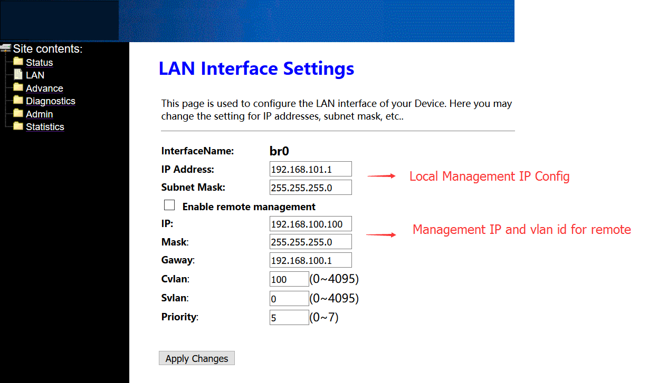

View ONU LAN Information

View ONU LAN User
Login ONU WEB. Click Advance → ARP Table, we can view the IP Address and MAC Address of every user that connect to the lan port of ONU.
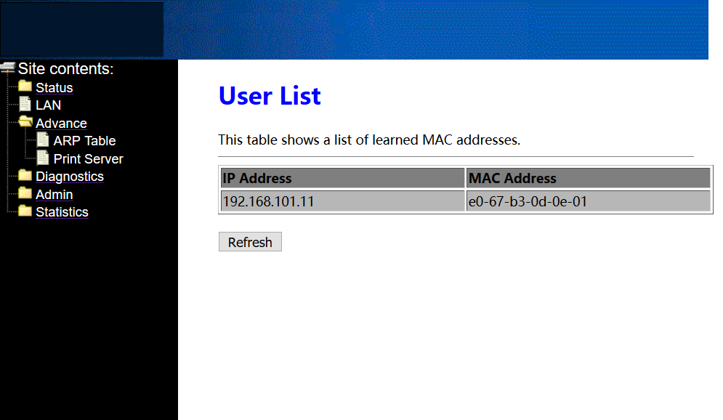

Note: Don’t care the Print Server option. This function is unavailable.

ONU Diagnostic

ONU Loop Diagnostic
Login ONU WEB. Click Diagnostics → Loop Detect, we can enable or disable loop detect function of ONU.
Note: Configured the loop detect function, we have to pay attention to configuration of this function that configured via OLT. Some kinds of OLT will disable loop detect function by default.
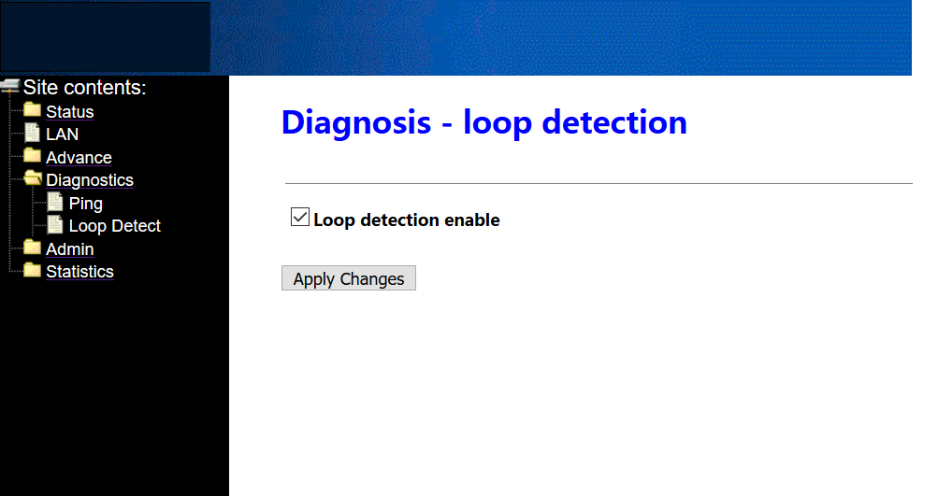

Ping Diagnostic
Ping diagnostic of Realtek SFU ONU is mainly used to test connectivity between ONU and client devices
Login ONU WEB. Click Diagnostics → Ping, type terminal IP address that connect to the ONU lan port, and click ‘GO’ button to test the connectivity
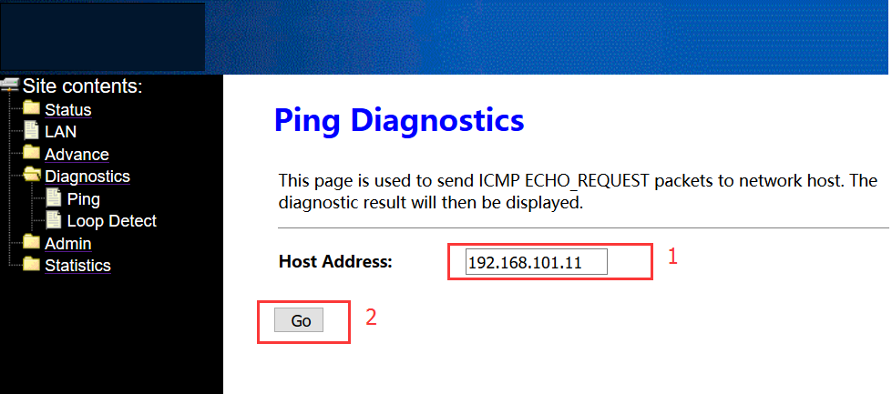
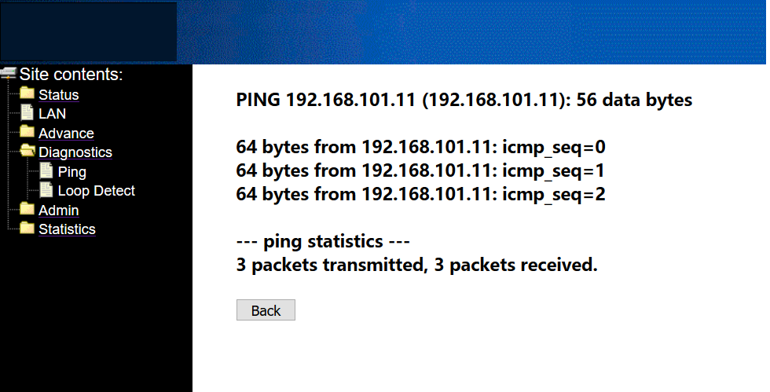

ONU System Management

Register LOID of ONU Config
The LOID of ONU is mainly used for the authentication of LOID and LOID+Password from OLT. By default, EPON ONU register to the OLT by MAC address but less LOID so that we needn’t configure the LOID. But the way to configure the LOID is as below
Login ONU WEB. Click Admin → EPON Settings, we can configure the LOID and LOID password, and click ‘Apply Changes’ button to finish the settings.
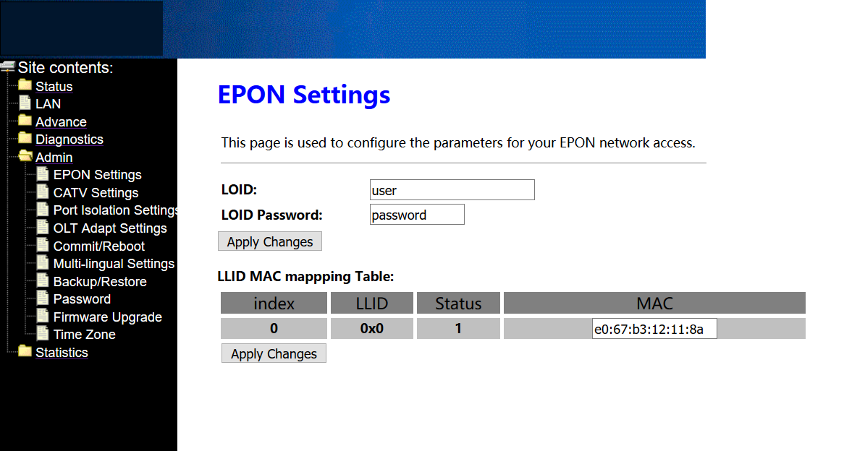

CATV Settings
Login ONU WEB. Click Admin → CATV Settings, we can enable or diable CATV port and configure other parameters of CATV, and click ‘Apply Changes’ button to finish the settings.
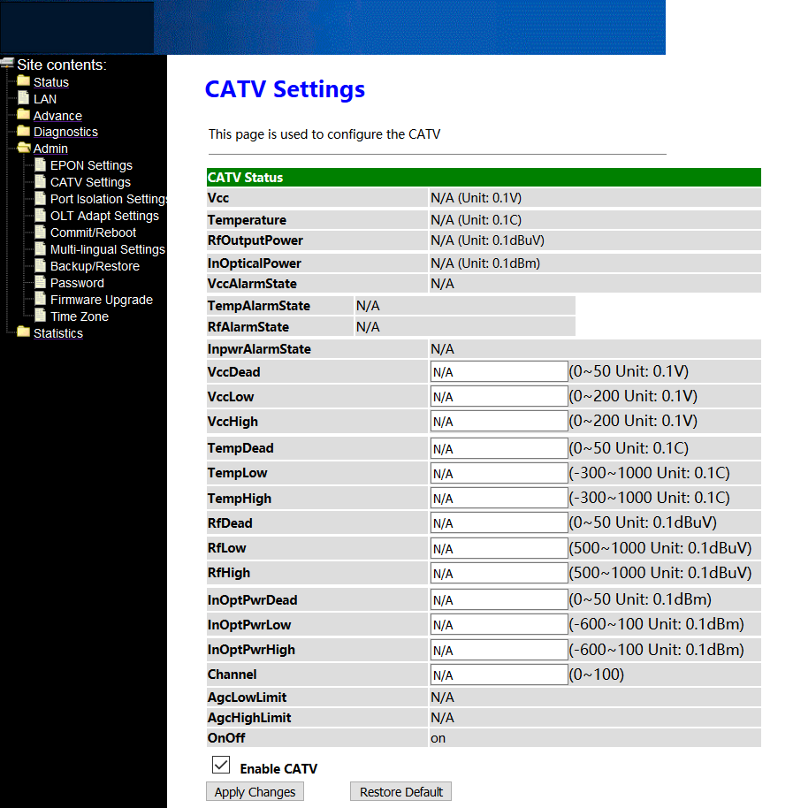

Port Isolation Settings
ONU ports isolation is mainly used to the terminal that connect to the ONU can communicate with each other or not.
Login ONU WEB. Click Admin → Port Isolation Settings, we can enable or diable port Isolation function in here, and click ‘Apply Changes’ button to finish the settings.
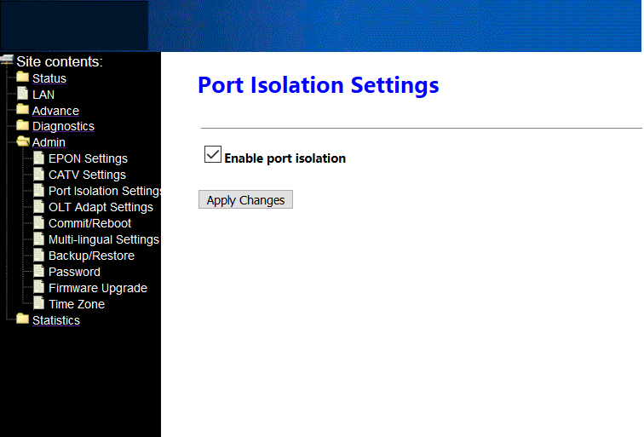

Reboot ONU
Login ONU WEB. Click Admin → Commit/Reboot, click ‘Commit and Reboot’ button to save the configuration and reboot the ONU.
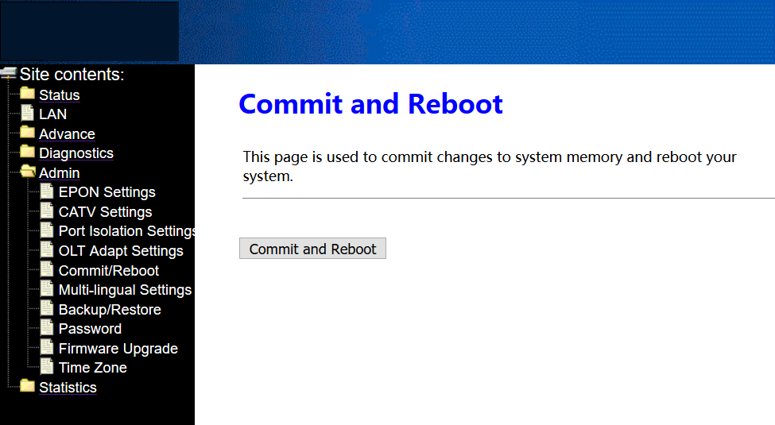

ONU Chinese and English Interface Switch
Login ONU WEB. Click Admin → Multi-lingual Settings. In here, we can change the language to Chinese or English, click ‘Update selected language’ button to finish the settings.
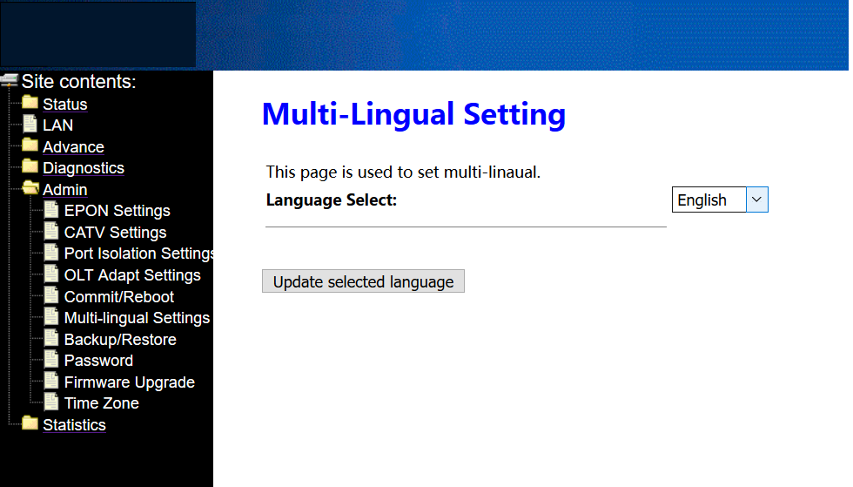

Reset Settings to Default
Login ONU WEB. Click Admin → Backup/Restore. In here, we can backup and restore settings, and click ‘Reset’ button to restore the ONU settings to default.
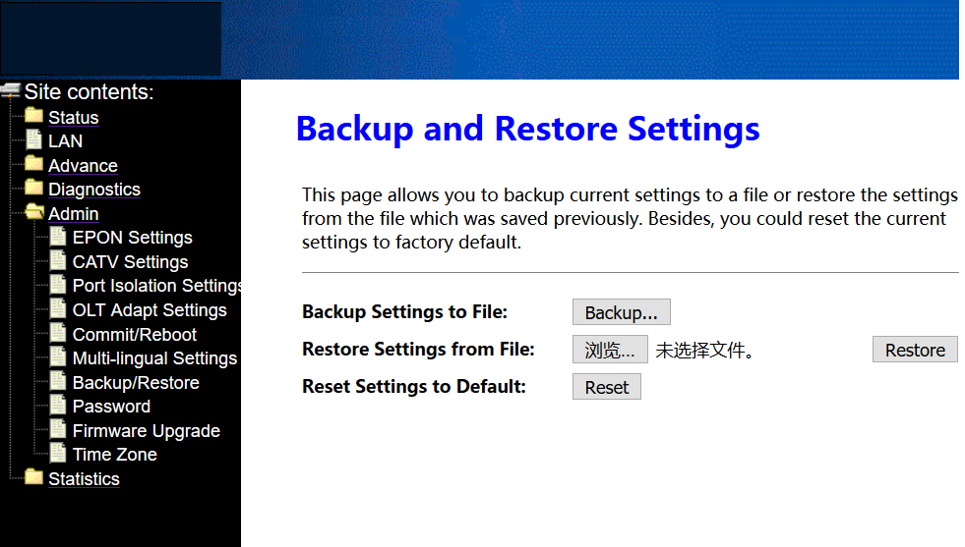

Modify the Account and password
Default system management account and password are adminisp/adminisp
Default system common account and password are admin/admin
Login ONU WEB. Click Admin → Password. In here, we can change the password for management account and common account, and click ‘Apply’ button to finish the settings.
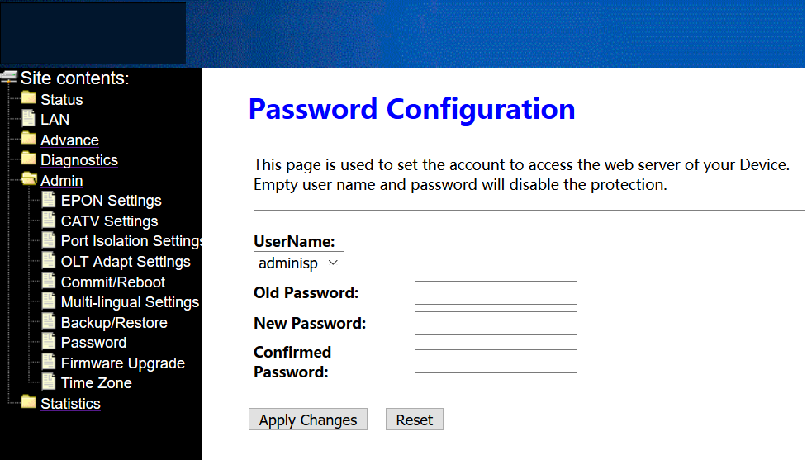

Upgrade the ONU
Firstly, we have to get a newest firmware from provider.
Login ONU WEB. Click Admin → Firmware Upgrade. In here, click ‘Select file button to select a upgrade file, and click ‘Upgrade’ button to upgrade the ONU.
Note: We needn’t extract Realtek project production’s firmware, just upgrade the .tar file. It will take 4 minutes to upgrade. After upgrading, the ONU will reboot automatically. We needn’t reboot it by manual.
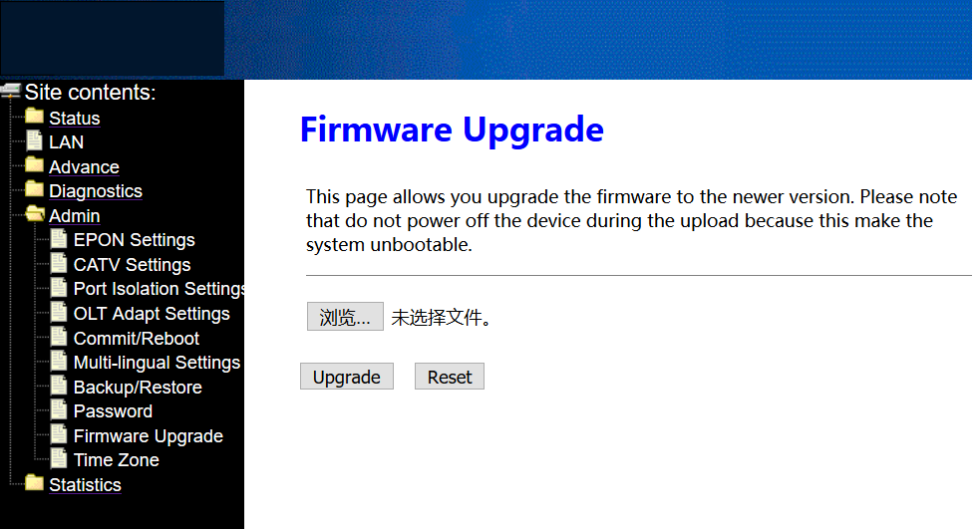

ONU Interface Traffic Statistics

ONU LAN Interface Traffic Statistics
Login ONU WEB. Click Statistics → Statistics. In here, we can view the information of transmitted and received packets of ONU lan ports.
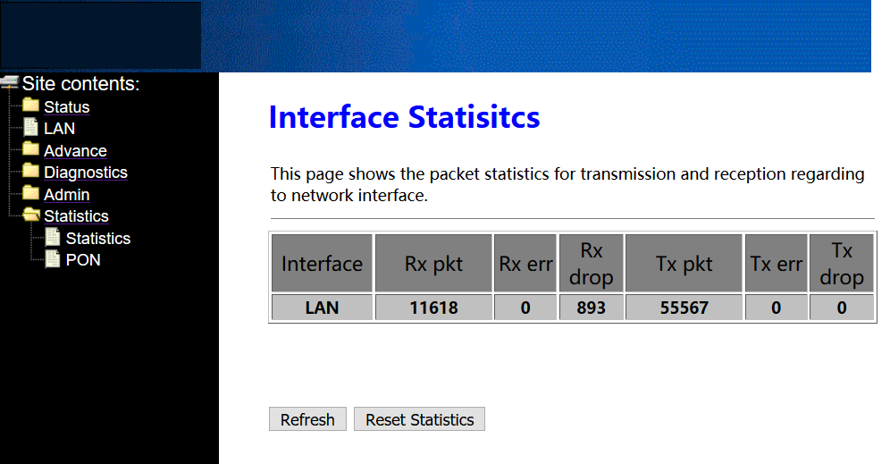

PON Statistics
Login ONU WEB. Click Statistics → PON. In here, we can view the information of transmitted and received packets of ONU PON port.
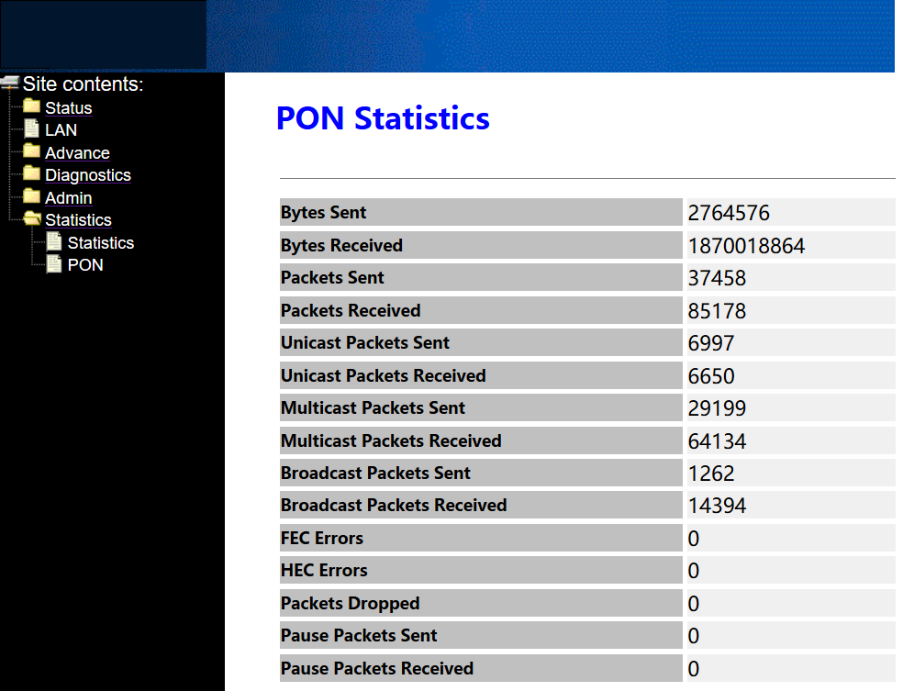

Concluding Remarks
Thanks for using products of Wodaplug Technology Corp.
Contact Information:
EU worldwide distribution:
Tomorrow systems s.r.o.
Karlstejnska 323
252 25 Orech – Prague west
Czech Republic

GSM: +420 608 262 004 , +420 775 262 900
Tel. : +420 257 211 010 (store, service)
Email: info@wodaplug.com
Website: www.wodaplug.com
www.524wifi.com / www.compexshop.com

